Slogan-Writing Event to Mark National Girl Child Day

1. **Summary of event**

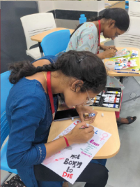

To celebrate the National Girl Child Day, which is observed on January 24 every year, the Student Affairs Committee organised a slogan-writing and themed postcard-making event. The primary goal of this initiative was to foster awareness and advocate for the rights of the girl child, emphasizing the significance of female education, health, and nutrition.

Participants were motivated to engage in discussions covering pertinent topics such as gender inequality, legal rights, female foeticide, and education.

The event witnessed enthusiastic participation from students across various grades, showcasing their creativity and passion for the cause. The slogan-writing competition brought forth powerful and thought-provoking phrases that resonated with the theme, encapsulating the essence of empowering and supporting the girl child. These slogans were not only a testament to the students' understanding of the challenges faced by girls but also served as impactful messages to the broader community.

In addition to the slogan-writing competition, the themed postcard-making event allowed students to express their thoughts visually. The postcards became a canvas for students to depict the importance of girls' rights through compelling images and messages. This artistic dimension added depth to the initiative, creating a tangible and visually striking representation of the advocacy for the girl child. The Student Affairs Committee ensured that the winning entries were prominently displayed within the school premises, serving as a constant reminder of the collective commitment to championing the rights and well-being of girls in society. Through such engaging events, the school community not only celebrated National Girl Child Day but also contributed actively to the ongoing dialogue surrounding gender equality and the empowerment of the girl child.

1. **Attendance sheet**

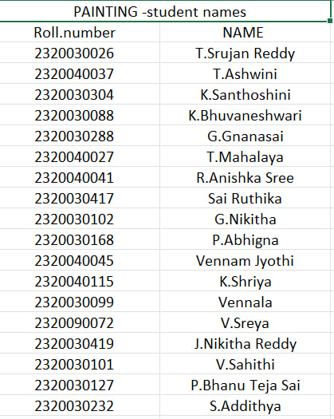

1. **Geo Tagged photo**

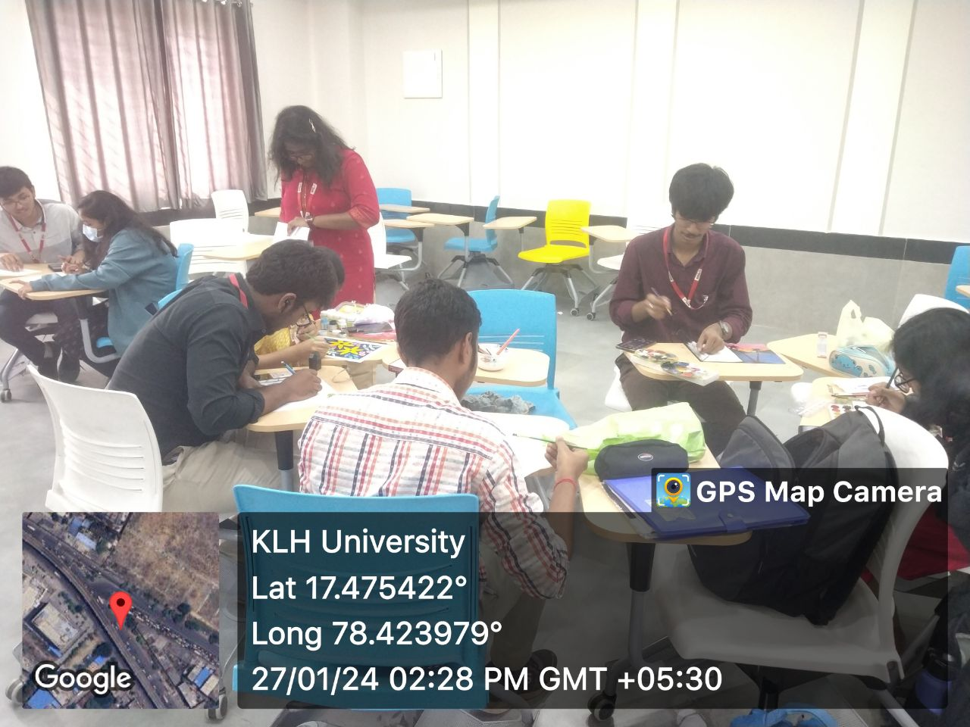

1. **Certificate (if any)**